Homework Assignment: Creating a Storyboard

Plot

Rising Action

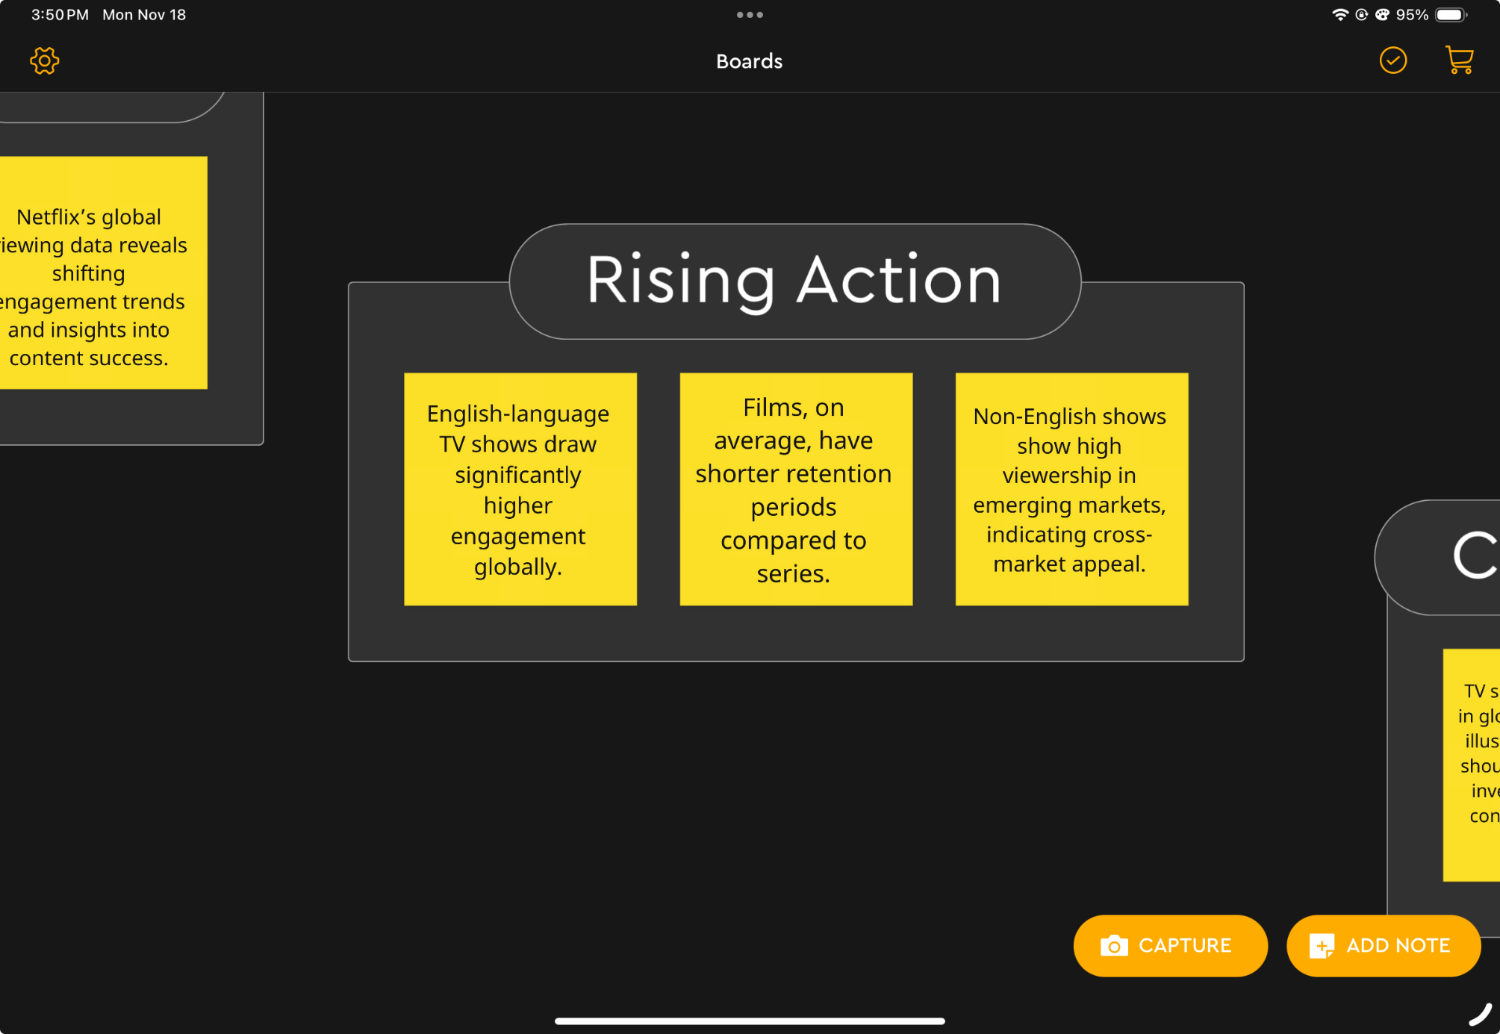

Climax

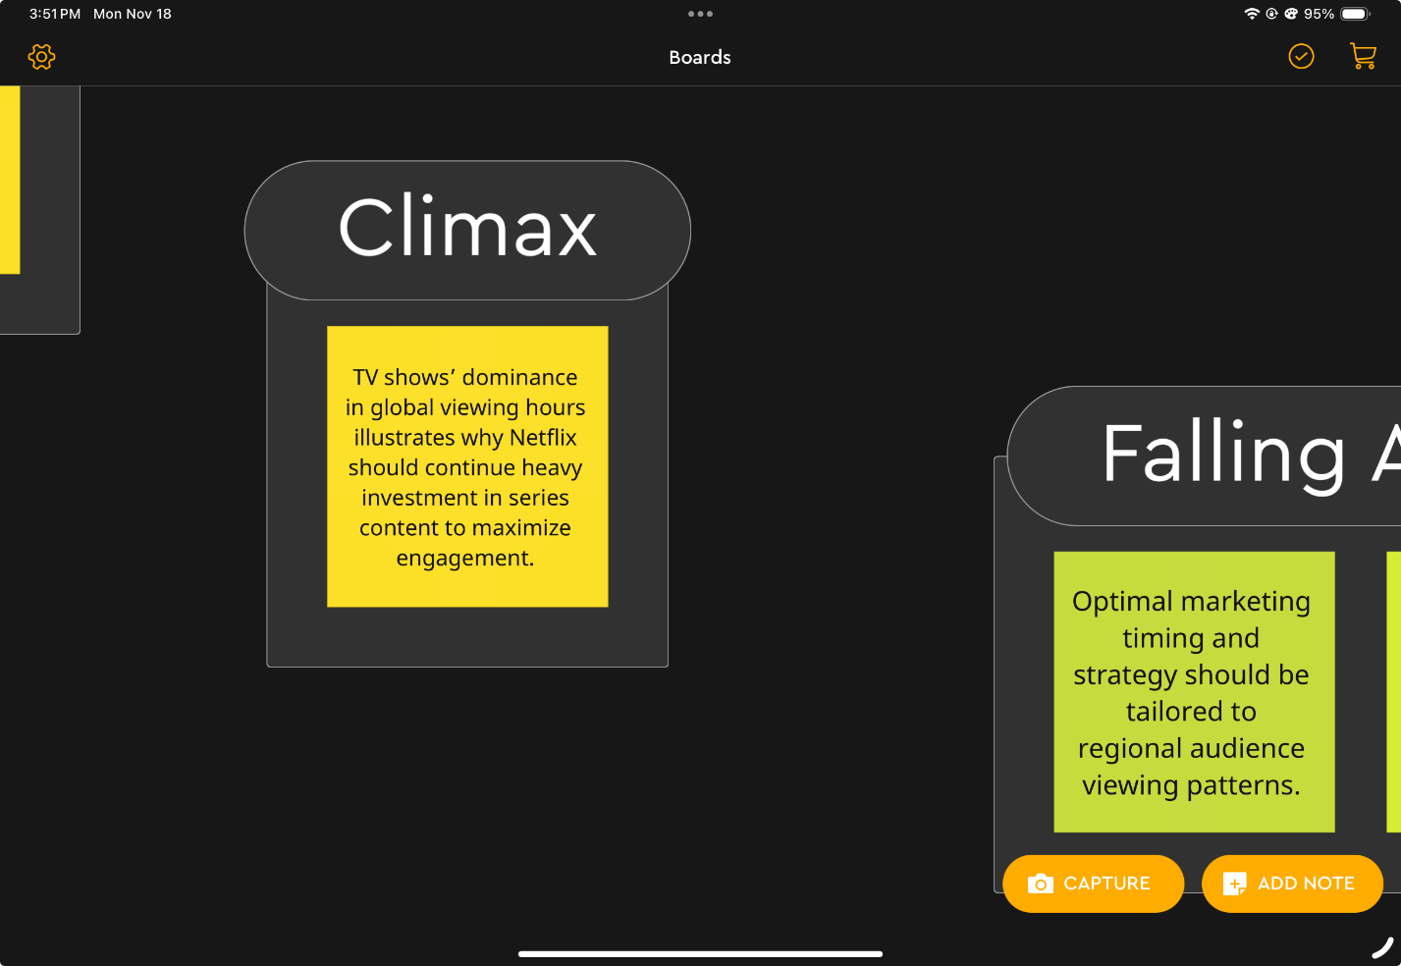

Falling Action

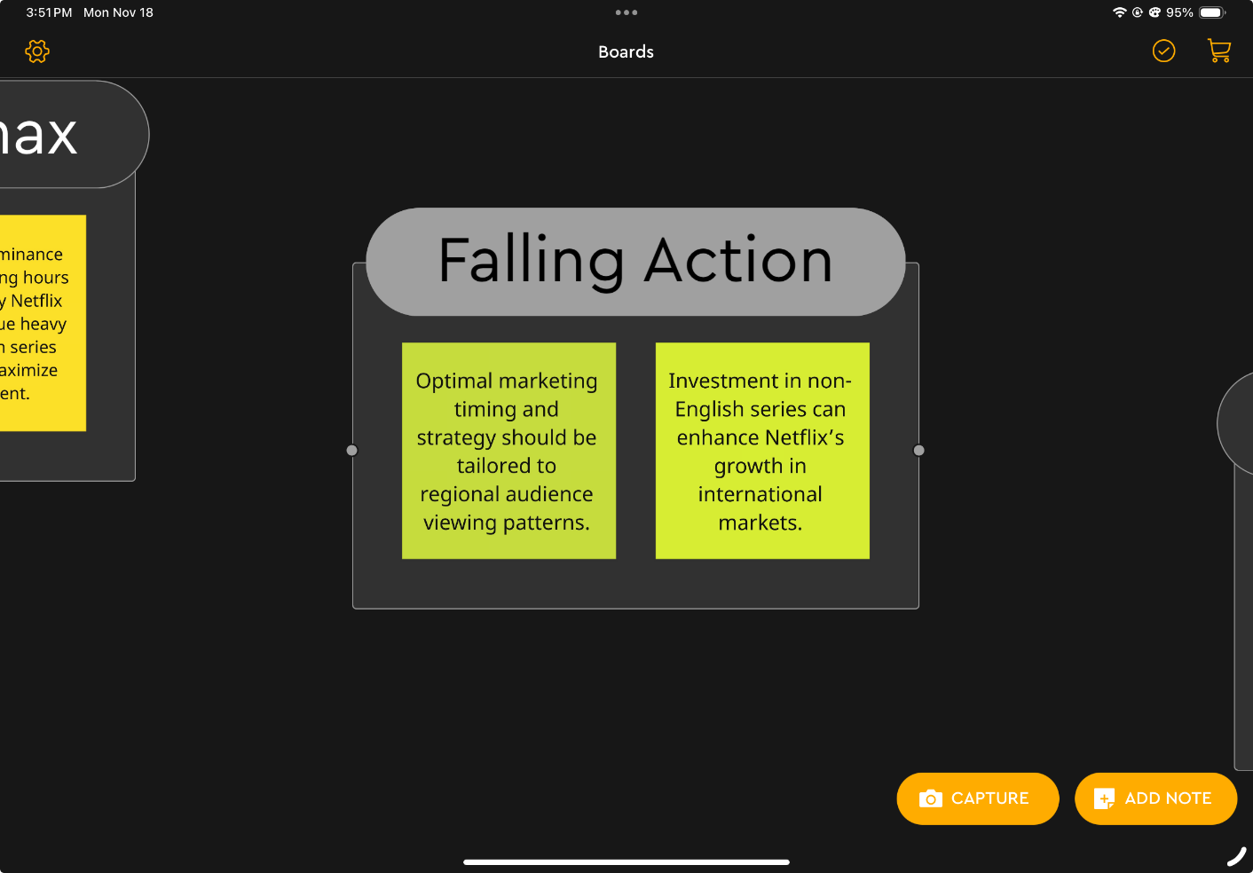

Ending

